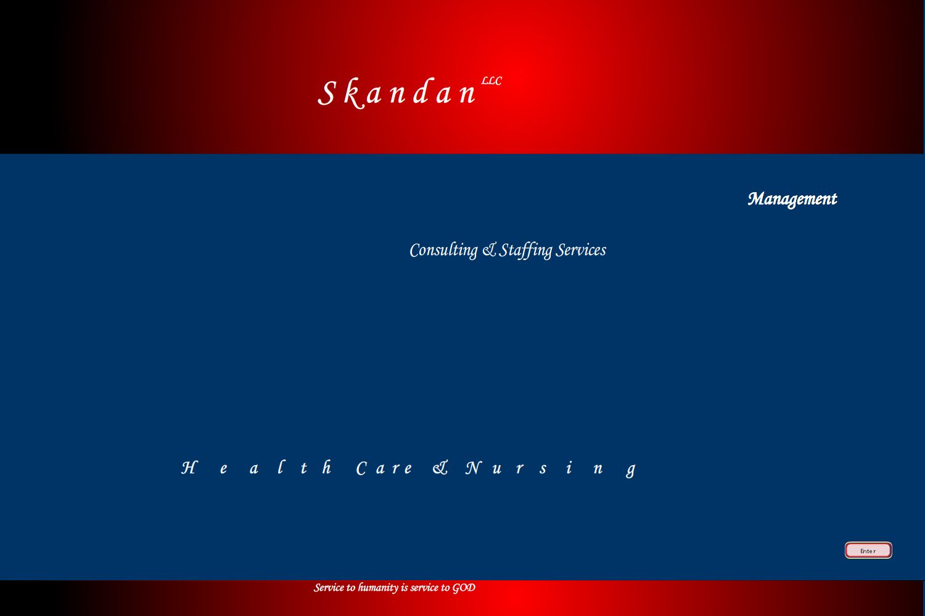
Electronic Handbook

Electronic Handbook

Our Mission
At Skandan llc, we endeavor to provide a launch pad for our employees, develop their skills to suite the market needs and train them to take up any challenge posed to them.

These dedicated world-class resources; we then translate into value for our clients, through our professional solutions, services and consulting businesses.

About Consulting & Staffing

There has always been a shortage of Skilled professionals world wide at all time
- Gold Miners during the Gold Rush to the west,
- Civil Engineers during Modern USA Concrete jungle era ,
- Mechanical Engineers during steel era,
- Doctors & Nurses during early 19th century
- IT Professionals in late 19th century
Well , the shortages are growing by the day , hour and minute ... for many countries and companies this shortage has created a bottle neck in growth and they are struggling to get out of it.
At Skandan llc we try to bridge the gap between skilled professionals and the market which is in need of them.
Our highly talented and experienced staff work round the clock in finding the gaps and filling them with the very best professionals in the market.

With such world class base of professional workers and motivated and dedicated staff members, we work hard to ease the struggle of our government and companies and their bottle neck with shortage of professional staff's, thereby rendering a hand in the growth of our Professionals, companies and our country.

Thanks

Staff Members @ Skandan llc

Thanks

Note: Please contact Management. Handbook is still being finalized.

